CHRONOLOGICAL HISTORY OF FOREST MANAGEMENT
AT ABEND HAFEN FARM

1972 Apr 49.7 Ac. Woodland purchased.
Sep Completed Master Conservation Course (North American School of Conservation) covering fish and game management, forest and park management, soil conservation, and job opportunities.
1974 May Completed Advanced Wildlife Management and Ecology Course (NASC).
Oct Fire protection – 4000' firebreak/access road and ½ acre pond built (FIP/ACP).
1975 Mar First forest management plan (Jim Klunk).
1976 Nov Property line painted. (Yellow)
1985 Feb Forest management plan updated (Scott Daniels).
Jun 32.5 Ac. purchased w/6 Ac. pine stand. (1984 timber cruise 776 trees 57,150 BF)
1986 Jan 22 Ac. timber cruise done (Parker Forestry Services). (Stand 2 on old forest management map)
Volume Estimate:
Pulpwood: Sawtimber:
Pine 49 cords 142 tons 192,257 BF
Hardwood 93 297 21,990
142 cords 439 tons 214,247 BF

Mar Pine Reforestation Plan done. (Scott Daniels).
Jul Timber sold to Dorchester Lumber Co.
1988 Jul 22 Ac. timber clearcut harvested. (Stand 2 on old forest management map)
Jul Timber stand improvement in 6 ac. pine stand (Stand 5 on old forest management map). Understory thinning by Mozel Hicks. 62.8 cords (approx. 180 tons) sold to Delaware Pulpwood Co.
Sep Repaired road (100 yards rutted).
1989 Jan Burned slash.
Jan Became member of American Tree Farm System.
Jan Became member of Maryland Forests Association.
Jan Purchased 8.98 Ac. agricultural field.
Mar 20 ac. reforestation (Forestry Services). 15,000 loblolly pine seedlings (FIP). Very wet year! (Note: 2 acres of former Stand 2 converted for use as moist soil impoundment/mini green tree reservoir)
Aug Clover planted on road.
Nov Dorchester SCD did elevation checks for ditch maintenance (John Willey/Bill Fitzhugh).
1990 Jan Seedling survival count: 247/ac.
Jan Named 1990 Dorchester County Outstanding Tree Farmer of the Year
Mar 20 ac. reforestation replant (Forestry Services). (Stand 2 – old map) 13,000 loblolly pine seedlings. Glatfelter Pulpwood Co. provided seedlings. (FIP)
Jun Ditch maintenance.
Jul 20 ac. TSI weed control w/oust (Forestry Services). (FIP)
Sep Attended University of MD Extension Service Coverts Project workshop.
Oct Forest management plan updated (Scott Daniels).
Nov Purchased 15.06 Ac. agricultural field.
1991 Jan 20 Ac. seedling survival count: 480/Ac.

Mar 100 bald cypress planted in impoundment (cell 3). 175 Russian olive, 50 crab apple, 250 Japanese black pine planted as windbreak along highway field.
Jun Ditch maintenance.
Aug 20 ac. TSI pine release w/arsenal (FIP). – 15 ac. done by Forestry Services using backpacks and 5 ac. aerial spray done by Summitt Helicopter.
1992 Jan Became a member of Anne Arundel Co. Forestry Board.
Feb Did aerial photography of farm. (John Bidwell)
Feb Developed slide presentations on waterfowl management, DNR’s Wild Acres Program (backyard habitat), and the Coverts Project (forestry and wildlife management) on the farm.
Mar Painted property lines using light blue “No Trespassing” paint.
Apr 200 bald cypress planted in impoundment. Did windbreak reinforcement planting along highway with 100 Japanese black pine and 100 leyland cypress. (SIP)
Jun Built and installed bat box. (SIP)
Jul Donated conservation easement on 91.2 ac. to Eastern Shore Land Conservancy and Maryland Environmental Trust ensuring continued allowance of silvicultural practices.
1993 Jul Built and installed two osprey nesting platforms. (SIP)
Nov Initial thinning of 20 ac. pine (stand 2) creating wildlife travel/observation lanes.
1994 Apr Wye Oak seedling planted by pond. Descendent of our State Tree.
Oct Barred owl box and bat box built and installed.
1995 May Sprayed 25 ac. for gypsy moths.
1996 May Sprayed 25 ac. for gypsy moths.
1997 May Sprayed 25 ac. for gypsy moths.
Sep TSI – Trees along 10,000' of road edges and field borders pruned (Forestry Services). (SIP)
Dec Retired and finally moved to the farm!
1998 Apr 3,600' ditching around field.
Apr Sprayed 25 ac. for gypsy moths.
Jul Became a member/Secretary of the Dorchester Co. Forestry Board.
2002 Feb Sold 200 fish trap poles (used for commercial fish nets). (Thinning Stand 2)
May Sprayed 44 ac. for gypsy moths.
2003 Feb Sold 225 fish trap poles.
2004 Feb Sold 650 fish trap poles.
2005 Feb Sold 200 fish trap poles.
2006 Feb Sold 620 fish trap poles.
2007 Feb Sold 130 fish trap poles. (TOTAL FISH TRAP POLES: 2025)
Jul Property line repainted in preparation for timber cruise.
Sep 14 ac. cruised for future timber sale (stands 1, 3, & 4 on old forest management map) 103,000 BF sawtimber

Dec 20 acres (stand 2 on old forest management map) thinned by Arthur Egolf for Glatfelter Pulpwood Co. (Steve Ditmer) totaling about 565 tons (25 truck loads). Residual basal area 70-90 sq. ft. per acre.
2008 Apr Deck area in stand 2 replanted w/”Madeline trees” and Arbor Day loblolly pine seedlings after pulpwood thinning.
May Sold 14 Ac. mixed hardwood and loblolly pine (stands 1, 3, & 4) totaling about 103K board feet to Holly Lane Farms (Lin and Jason Spicer). Allowed five years to cut and 75 mature hardwoods (5 per acre) to be left scattered throughout the stands for wildlife.
Oct Kathy attended Maryland Woodland Stewards workshop at Camp Pecometh.
2009 Mar Replaced 13 wood duck nesting boxes.
2010 Jul 14 acres harvested -- sawtimber, firewood, & pulpwood. Tree tops scattered throughout area. 95 large oaks/beech left standing for wildlife.
Tree tops cut up for firewood all winter. “U-Pick Firewood”
2011 Apr 14 acres (stands 1, 3 & 4) reforested with 9600 loblolly pine seedlings by Horizon Forestry, LLC. Seedlings from John S. Ayton State Tree Nursery. Glatfelter Pulpwood Co. paid for half the seedlings. (EQIP)
Aug Hurricane Irene uprooted 14 large oaks/beech. Salvaged most during fall.
Sep Timber Stand Improvement -- 5 ac. within stand 2 sprayed with Arsenal to kill gum saplings. Delmarva Forestry (EQIP)
Dec Seedling survival count (stands 1,3,4 reforestation area) 520/ac. (Scott Daniels)
2012 Jan Cruised 6 ac. pine stand (Stand 5 on Forest Management Map) for sawtimber:
100% tree est. 549 trees / 108600 board feet (John Bidwell/Rick Abend)
Apr Jean Small (mother-in-law) attended Maryland Woodland Stewards workshop.

********************************************************************************
Jul Forest Stewardship Plan updated -- including new forest management map. (Old Stand 5 now Stand 1 / Old Stands 1,3,4 now Stand 2 / Old Stand 2 now Stand 3) (Scott Daniels)
Jul Ten new culverts installed throughout woodland to improve trail access.
Sep 14 Ac. TSI pine release by backpack spraying w/Arsenal & Escort by Delmarva Forestry. (Oak sprouts saved.) (WIP)
Oct Hurricane Sandy uprooted 15 large oaks.
2013 Aug Initial wildlife observation/travel lanes in Stand 2.
Named Dorchester County Outstanding Tree Farmers of the Year for 2014
Sep Oak sprout stem selection in Stand 2.
Sep Maryland Tree Farm “Discover Your Woods” Tour
Named Maryland State Outstanding Tree Farmers of the Year for 2014
Oct Salvage of Hurricane Sandy uprooted trees. (Firewood)
Nov Became Eastern Regional Representative on the Maryland Tree Farm Committee
2014 Feb More oak sprout stem selection in Stand 2.
Sep Member of Woodland Incentive Fund Working Group (WIP Funding Sources)
Wildlife observation/travel lanes in Stand 2 completed.
2015 Jul Runner-up for 2015 Northeast Regional Outstanding Tree Farmers of the Year
2016 Nov Trimmed/pruned trees along observation lanes in Stand 2
2017 Feb Fusiform Rust fungus in Stand 2. Thinned/pruned 6 acres (infected pine trees only) and Pre-Commercial thinned/pruned remaining 8 acres. (EQIP)
2018 Jan Became Vice-Chair of Maryland Tree Farm Committee
Apr Pre-commercial thinning on 6 acres by Express Forestry Service - Stand 2 (WIP)
Oct Forests for the Bay 2018 Chesapeake Forest Champions Award

Federal Cost-Share Programs Used:

Agricultural Conservation Program (ACP)
Conservation Reserve Program (CRP)
Conservation Reserve Enhancement Program (CREP)
Forestry Incentive Program (FIP)
Stewardship Incentive Program (SIP)
Environmental Quality Incentive Program (EQIP)

Maryland State Cost-Share Programs Used:

Wildlife Habitat Incentive Program (WHIP)
Woodland Incentive Program (WIP)

Other:

Waterfowl Habitat Restoration Program – 10 year contract – annual expenses considered a donation to the State of Maryland (tax deductible)

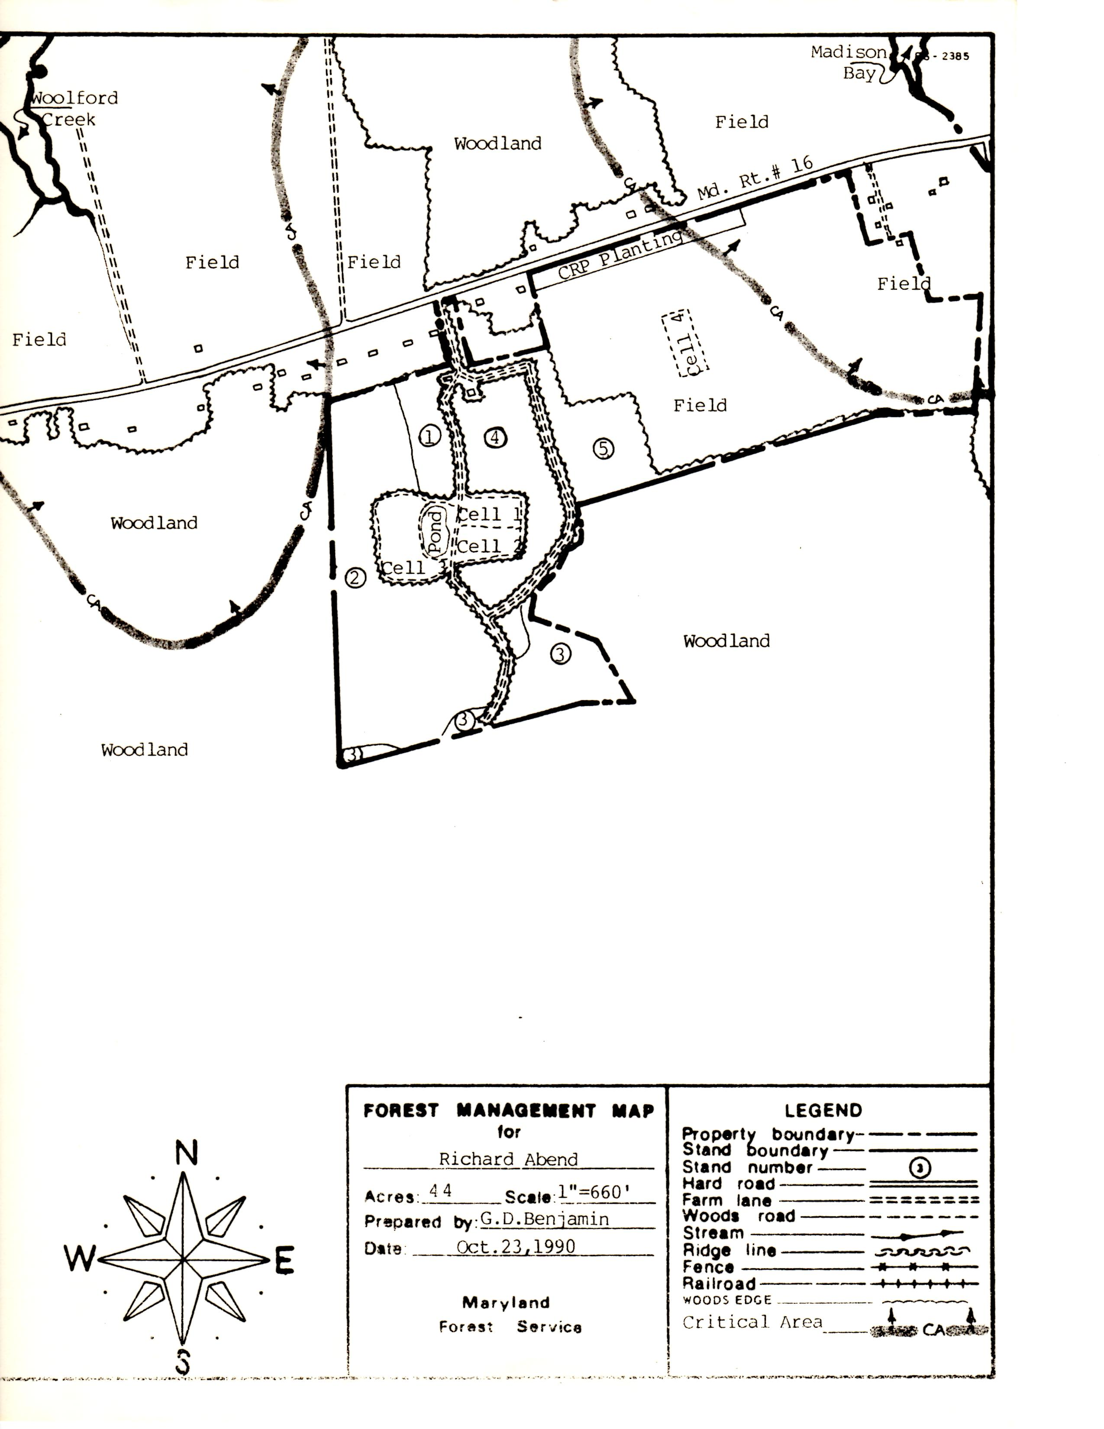 OLD FOREST MANAGEMENT MAP (USED PRIOR TO JULY 2012)

NEWEST FOREST MANAGEMENT MAP – JULY 2012

