FOREST AND WILDLIFE MANAGEMENT
AT
ABEND HAFEN FARM
Rick and Kathy Abend

Madison, Maryland
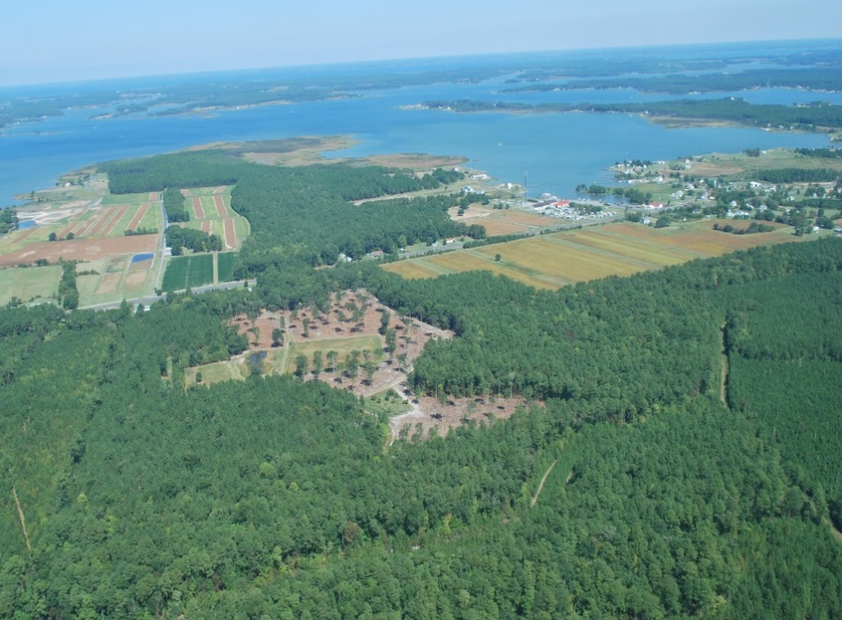

MULTIPLE USES

WILDLIFE HABITAT
Agriculture
Timber
Hunting and Fishing
Bird Watching
Wildlife Photography
Conservation Education
Stress Relief!

WILDLIFE HABITAT:
Fields: 32 Ac. in crops
14 Ac. in CRP
Timber: 6 Ac. loblolly pine saw timber (about 1950)
20 Ac. loblolly pine pole timber (1989) (scattered hardwoods)
14 Ac. loblolly pine seedlings (2011) (scattered hardwoods)
3 Ac. field border along highway (autumn olive, Japanese black pine, Russian
olive, Leyland cypress, crab apple, bald cypress) (1991-92)
1 Ac. bald cypress (1991-92)
2 Ac. mature hardwood/loblolly pine homesite buffer
Water: ¾ Ac. stocked fish pond (also for fire protection)
Four moist soil impoundments (5.5 Ac.) planted with sorghum/Jap millet mix
Other: ¼ Ac. apple orchard (also fig trees)
Over one mile of roads/dikes (clover)
1 Ac. food plots/clover surrounding impoundments
Nesting structures for wood ducks, bluebirds, bats, squirrels, and ospreys
Backyard pond, fountain, bird baths, feeders, and bird houses

AGRICULTURE:
Corn Soybeans
Sorghum Winter Wheat

TIMBER:
1988 22 Ac. clearcut harvest (214K BF Sawtimber and 142 cords (439 Tons) Pulpwood/chips)
6 Ac. understory pulpwood thinning (62.8 cords/180 tons)
1989 20 Ac. reforestation
2002-07 2,025 fish trap poles sold (for commercial pound nets)
2007 20 Ac. pulpwood thinning (25 truck loads/565 tons)
2010 14 Ac. clearcut harvest (103K BF)
2011 14 Ac. reforestation
2012 6 Ac. timber cruise (108K BF)
14 Ac. Timber Stand Improvement – pine release spraying
2017-18 14 Ac. pre-commercial thinning
MANY cords of firewood have been cut since 1972!
HUNTING and FISHING:
Deer
Turkey
Largemouth Bass and Bluegill
BIRDWATCHING:
Songbirds
Waterfowl
Wading Birds
Raptors
Woodpeckers

WILDLIFE PHOTOGRAPHY:
If it slithers, crawls, walks, leaps, runs, climbs, swims, or flies, it’s game!
CONSERVATION EDUCATION: (Maryland Woodland Stewards Program / American Tree Farm System Outreach)
Sign Displayed along Highway
Newspaper Articles
Newsletters
Radio -- WCEM for Dorchester Co. Forestry Board
Television -- WBOC for Eastern Shore Land Conservancy
One-on-One Conversations with Friends and Neighbors
Tours --
State Forestry Board Assn., Coverts Spring Field Day, Dorchester Co. Agriculture
Awareness Tour, Dorchester Co. Envirothon Team Training, Northeast Regional
Foresters Meeting, DNR Budget Personnel, Camp Nanticoke Boy Scout Eco-tour,
Delmarva Forestry Seminar, Virginia Eastern Shore Land Trust, Eastern Shore Land
Conservancy, Maryland Tree Farm System “Discover Your Woods” Tour, UMES Small
Farm Bus Tour, P. R. China State Forestry Administration
Slide Presentations --
Maryland Woodland Stewards Workshops, Anne Arundel Co. and Dorchester Co.
Elementary Schools, Delmarva Birding Festival, Quail Unlimited Wildlife Workshop,
Friends of Blackwater Spring Fling, Maryland Land Trust Alliance Workshop, Friends of
Blackwater Annual Meeting, UMd Ext. Sustainable Forestry Workshop
Conservation Displays --
Cambridge Earth Day Celebration, Maryland Forests Association Fall Forest Festivals,
Cambridge National Outdoor Shows,
STRESS RELIEF! ---- 106 acres of Heaven on Earth

THE MESSAGE…..
Volunteering with other organizations (e.g., Eastern Shore Land Conservancy), working with local officials (e.g., project forester, extension agent, soil conservation district, & U. S. Fish & Wildlife Service) has greatly enhanced opportunities to spread the Maryland Woodland Stewards and American Tree Farm System message and meet the multiple use goal of conservation education at Abend Hafen Farm!

Rick & Kathy Abend
1111 Taylors Island Rd.
Madison, MD 21648

Rick: 443-521-2201 rdabend@yahoo.com
Kathy: 443-477-1065 kabendrn1@yahoo.com

FOREST STEWARDSHIP MAP:
Stand 1 - 6 Ac. Mature loblolly pine
Stand 2 - 14 Ac. Seedling/sapling loblolly pine
Stand 3 - 20 Ac. Pole loblolly pine

